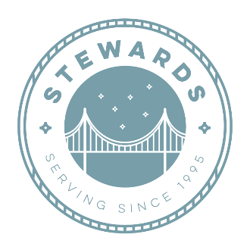

Suggested Donation Items

Sister Josie’s Food Pantry accepts nearly all types of food product, including nonperishable items and produce. Please also consider nutritional food items that are low in sodium/salt and sugar.
GRAINS FRUITS AND VEGETABLES
Breakfast cereal Canned vegetables
Oatmeal Canned fruits
Pasta Shelf-stable vegetable or fruit juice
Rice Diced tomatoes
Crackers Tomato sauce
Flour Spaghetti sauce
Grits Dried fruits
Healthy snacks Fruit cups

MILK PROTEINS
Shelf-stable milk Canned meat (tuna and chicken)
Evaporated milk Dried beans, lentils, or peas
Dry milk Canned beans
Canned chili
COOKING OIL Peanut butter
Olive oil Nuts
Canola oil Trail mix
Coconut oil Canned soups/stews
Vegetable oil

We also accept: Items for the Homeless
Disposable masks Single Serving Items for homeless
Hand sanitizer Individual cheese and crackers
Paper products Individual tuna or chicken with crackers
Diapers Granola bars, breakfast bars, protein bars
Toiletries Individual bag of nuts
Bottled water Small Pop-Top Cans for homeless
Cleaning products Individual ready to eat ravioli or pasta
Cleaning products Individual ready to eat mac n cheese
Individual chili

